​Here's an example of an add tool to illustrate the core idea behind tool calling in an agent:
A tool is basically a python function. A tool should consist of following components:
- Descriptive name
- Standardized input (typically a string since it is coming from an LLM)
- Comprehensive documentation (what the tool does, expected input/output and known limitations
- Function Body
- Consistent Output (usually in dictionary format)
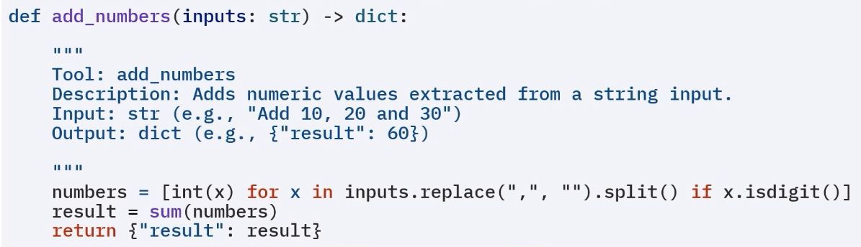Here part written inside ‘’’ ‘’’ is a docstring in order for the LLM to understand what this tool does.

You can simply use the tool class in LangChain to wrap regular Python functions into agent-compatible ​tools. ​By specifying the tool's name, function, and a short description, the tool becomes ​callable by agents in response to LLM prompts.
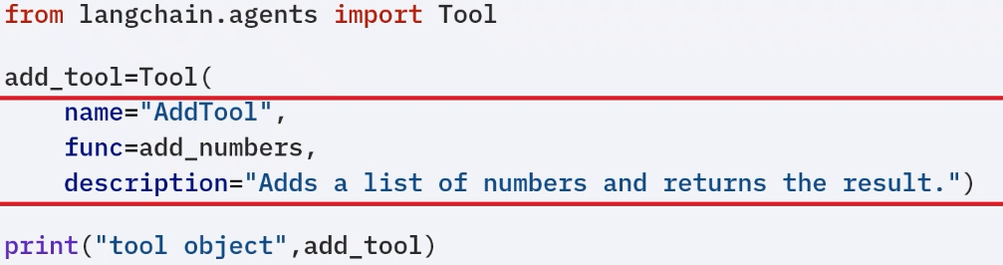
By using the invoke function you can call the tool directly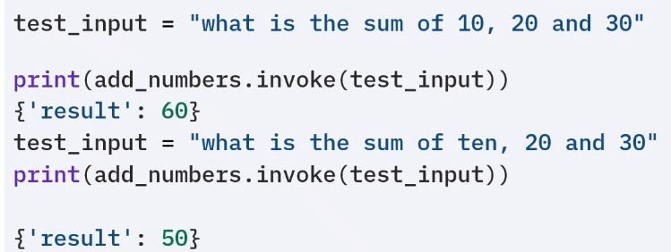.
Now instead of writing long code above using Tool class to wrap your function you can simply use @tool decorator on a function to tell the LLM hey you can use this tool. Tool name will become the function name, description it will take from docstring.
